Auc performance with Random forest model
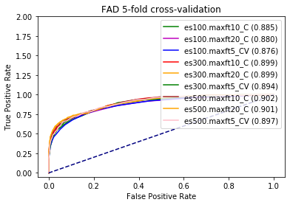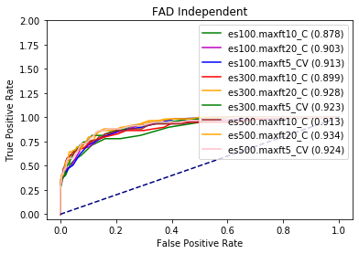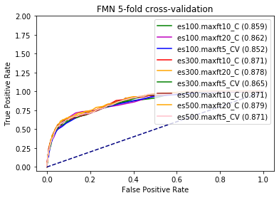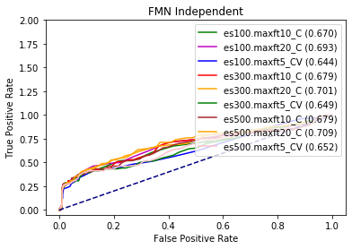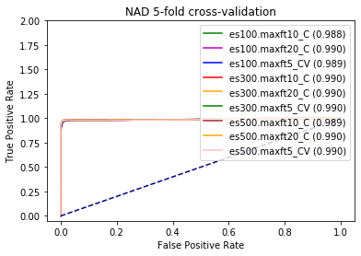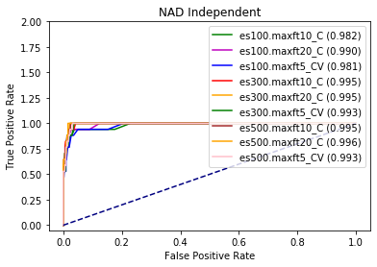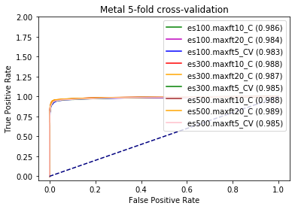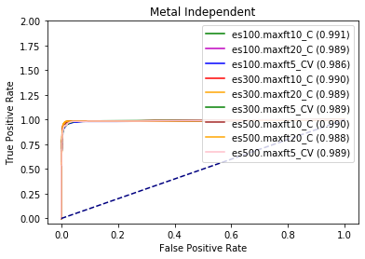
Auc performance with Traditional Auto encoder
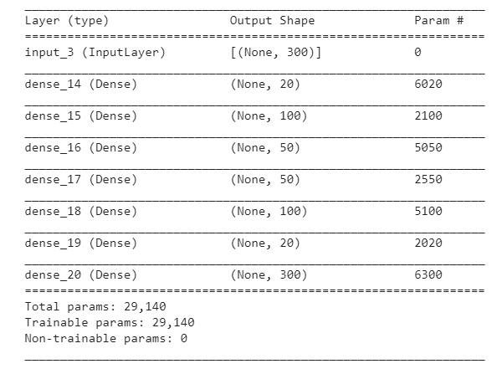
FAD | 5-fold cross validation | Independent
Model 1 | 0.688 | 0.688
Model 2 | 0.654 | 0.654
Model 3 | 0.678 | 0.678
Model 4 | 0.696 | 0.696
Model 5 | 0.670 | 0.670
Model 6 | 0.687 | 0.687
Model 7 | 0.684 | 0.684
Model 8 | 0.704 | 0.704
Model 9 | 0.709 | 0.709
 | 0.685 | 0.690
Average | 0.685 | 0.686

FMN | 5-fold cross validation | Independent
Model 1 | 0.717 | 0.752
Model 2 | 0.680 | 0.653
Model 3 | 0.697 | 0.699
Model 4 | 0.689 | 0.688
Model 5 | 0.690 | 0.692
Model 6 | 0.666 | 0.704
Model 7 | 0.679 | 0.705
Model 8 | 0.649 | 0.666
Model 9 | 0.661 | 0.668
Average | 0.681 | 0.692

Auc performance with Convolutional Auto encoder
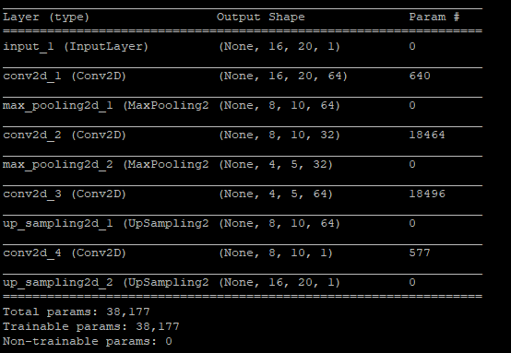
FAD | 5-fold cross validation | Independent
Model 1 | 0.699 | 0.826
Model 2 | 0.690 | 0.825
Model 3 | 0.699 | 0.825
Model 4 | 0.702 | 0.825
Model 5 | 0.699 | 0.825
Average | 0.698 | 0.825

FMN | 5-fold cross validation | Independent
Model 1 | 0.666 | 0.447
Model 2 | 0.667 | 0.447
Model 3 | 0.666 | 0.447
Model 4 | 0.667 | 0.447
Model 5 | 0.666 | 0.447
Average | 0.667 | 0.447

